First Evidence LPR GoNoGo Monitor

Software Version 3.0.1
18 September, 2009

Contents

System Overview 2

System Overview
The First Evidence GoNoGo Monitor is the main application that allows the user to see what’s going on with the LPR Service. At a glance, the user is given a Red/Green (or Go/NoGo) status on all the major components to the system, as well as seeing real-time video and plate readings.
Clicking on one of the four camera images toggles that image between full screen (shown below) and quad-view mode. When in full screen mode, the Save Current Image button appears on the lower left and saves the image that is present at the moment the button is first pressed.

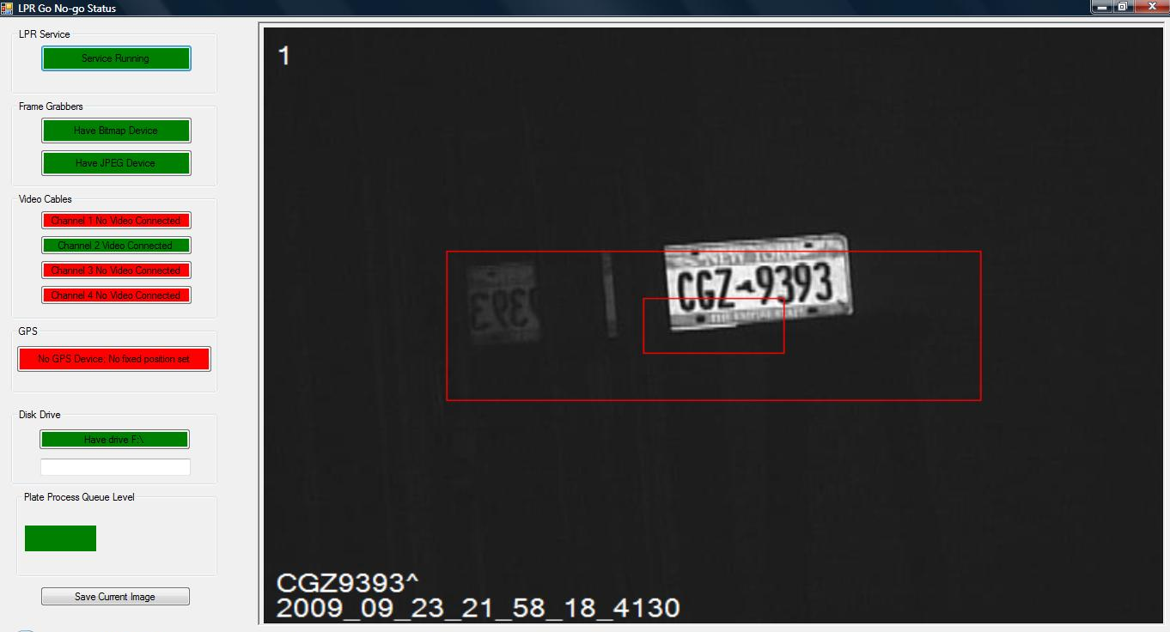

The small red box indicates the minimum plate size. The large red box indicates the maximum plate size.
The most recent plate reading.

The time stamp of the most recent image (UTC time).

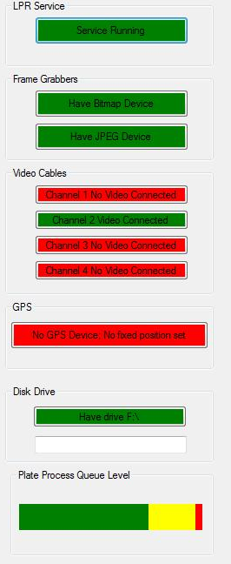
Indicates the service is running.
Indicates if the Bitmap frame-grabber is connected and in service.
Indicates if the Jpeg compression frame-grabber is connected and in service.
Note: the jpeg compression and Bitmap frame-grabber functions may share one single S2255 device.
Indicates video is connected on Channel 2.
Indicates No GPS device is attached and no fixed site coordinates have been entered.
Indicates the storage drive is attached and functioning.
Drive Hot-swap status
To-be-processed Queue Level indicator. As motion is detected, frames are sent to this queue to await LPR Processing. If too many plates/motion frames are detected in a short time, this queue may rise in level. Red indicates images are being dropped or about to be dropped.

